**Project Documantation**

**SDLC (Software Development Life Cycle) 6 Rules**

1. **Planning**
2. **Analysing and Defining Requirements**
3. **Designing Architecture**
4. **Implementing and Developing Product**
5. **Product Testing and Integration**
6. **Development and Maintenance of Product**

**Project Documentation for Travel Agency Website**

1. **Requirement :-** Understand the requirements of the Travel Agency from both Travelers and Travel Agents.

**Features:-**

* + - User Registration & Login
    - Trip Booking
    - Manage Bookings
    - Custom Travel Packages
    - Payment Processing
    - Reviews & Ratings
    - Search & Filters
    - Travel Packages Display
    - Personalized Recommendations
    - Customer Support
    - Admin Dashboard
    - Travel Agent Portal
    - Reports & Analytics
    - Special Offers & Discounts
    - Notifications & Alerts

1. **Analysis**

Requirement analysis

Time requirement

Budget

How many users

**Step 1 : Find total no of user**

Guest

Travelers->  website

Admin -> admin panel

Travel Agents ->  Travel Agents panel

**Guest Role:-**

* **Browse Travel Options**: Look through flights, hotels, tours, and vacation packages.
* **Search Destinations**: Use filters to find places based on dates, budget, or preferences.
* **Check Prices**: See the costs of different travel options.
* **View Details**: Read descriptions and other details about trips.
* **Read Reviews**: Check what other travelers have said about destinations or services.
* **See Special Offers**: View promotions and discounts.
* **Contact Support**: Ask questions or get help via customer support.

**Travelers** **Role:-**

* **Sign up, log in, and log out**: Travelers can create an account, log in to access their personalized dashboard, and log out when done.
* **Book Travel**: They can book flights, hotels, tours, and travel packages.
* **Manage Bookings**: Travelers can view, edit, or cancel their bookings.
* **Save Favorites**: Save preferred destinations or packages for future reference.
* **Receive Recommendations**: Get personalized travel suggestions based on their preferences and previous trips.
* **Access Special Offers**: View exclusive deals or discounts available only to registered users.
* **Write Reviews**: Share their experiences by leaving reviews and ratings for destinations, hotels, services, and tours.
* **Track payments and invoices**: View payment history and download invoices for completed bookings.
* **Track Travel History**: View their previous and upcoming trips in one place.
* **Update Profile**: Edit their personal details, travel preferences, and payment information.

**Travel Agents** **Role:-**

* **Sign up, log in and log out**: Travel agents can create an account, log in to their agent dashboard, and log out when finished.
* **Manage bookings for Travelers**: They can book trips, flights, hotels, and travel packages on behalf of their **Travelers**.
* **Create custom travel packages**: Travel agents can offer customized packages based on the needs of their **Travelers**.
* **View and manage Travelers details**: They can access the profiles of travelers, track their preferences, and manage bookings for them.
* **Handle payments**: Agents can process payments for bookings and manage invoices on behalf of **Travelers**.
* **Communicate with Travelers**: They can directly interact with travelers to offer advice, answer questions, and handle special requests.

# **Track commission and earnings**: Travel agents can track their commission and earnings from the bookings they manage.

# **Access exclusive agent offers**: Agents may get access to exclusive deals or discounts for their **Travelers**.

* **Update Profile**: Edit their personal details.

**Admin Role:-**

* **Log in and log out**: Log in to manage the website, and log out when done.
* **Manage users**: Add, edit, or remove user accounts, including travelers and travel agents.
* **Oversee bookings**: View and manage all bookings made by travelers and travel agents.
* **Add and update travel packages**: Create new travel packages and update existing ones with current prices and details.
* **Handle payments**: Process and review payments made through the website.
* **Monitor website activity**: Track user activity, bookings, and website performance to ensure everything runs smoothly.
* **Provide customer support**: Assist users with inquiries or issues they encounter on the site.
* **Generate reports**: Create reports on sales, user activity, and other metrics to analyze the business.
* **Update Profile**: Edit their personal details,information.

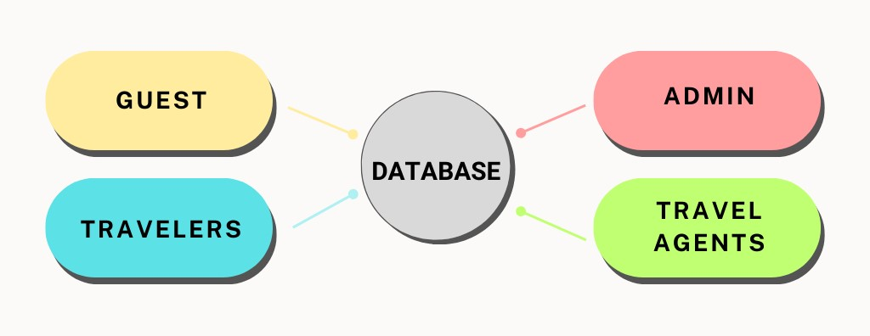

Step – 3

* Use case Diagrams

1. **Use case Diagram of Guest**

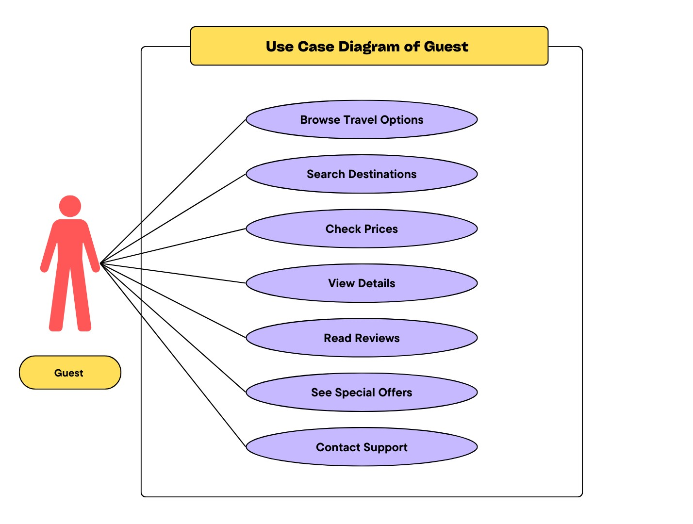

1. **Use case Diagram of Travelers**

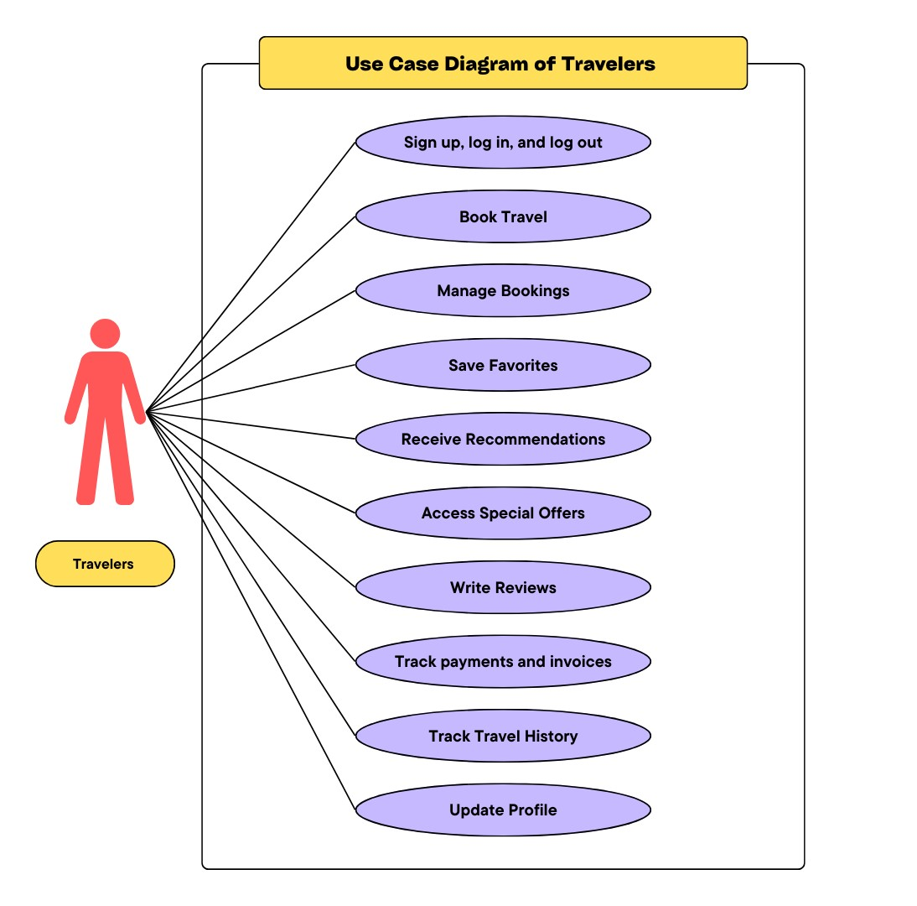

1. **Use case Diagram of Travel Agents**

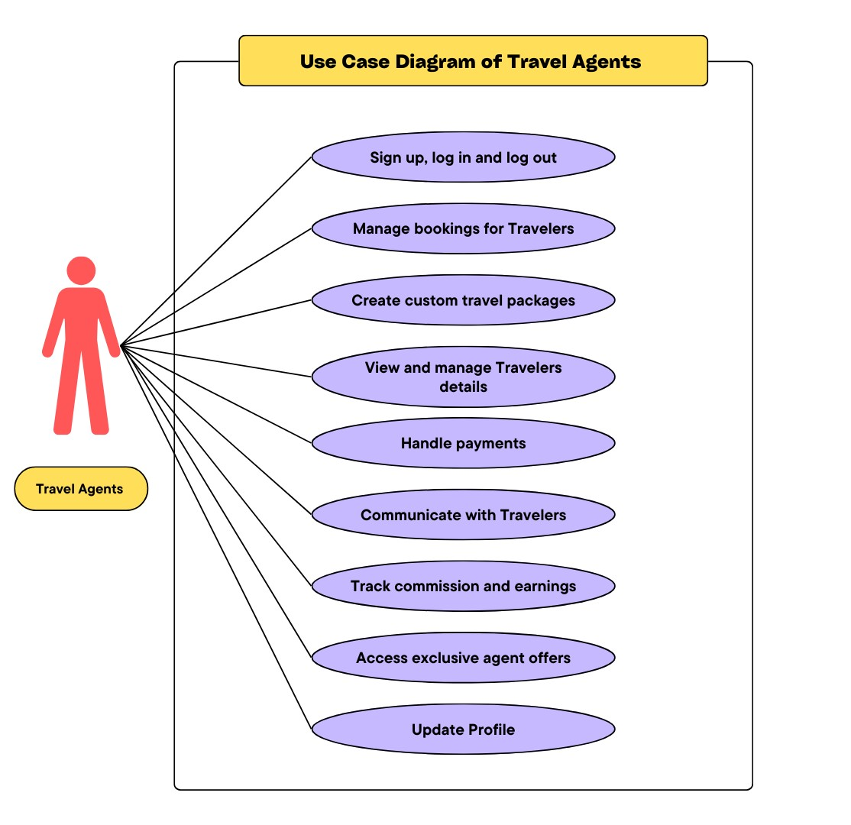

1. **use case Diagram of Admin**

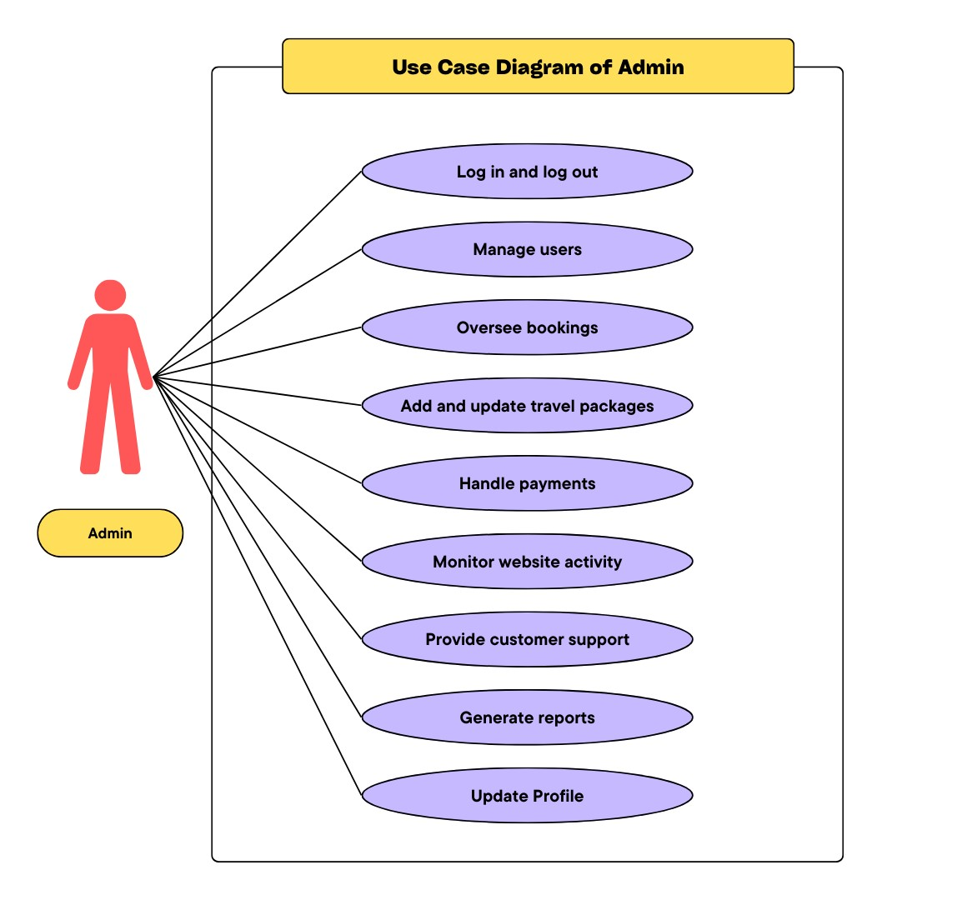

* **DFD diagrams**

**0-level diagram**

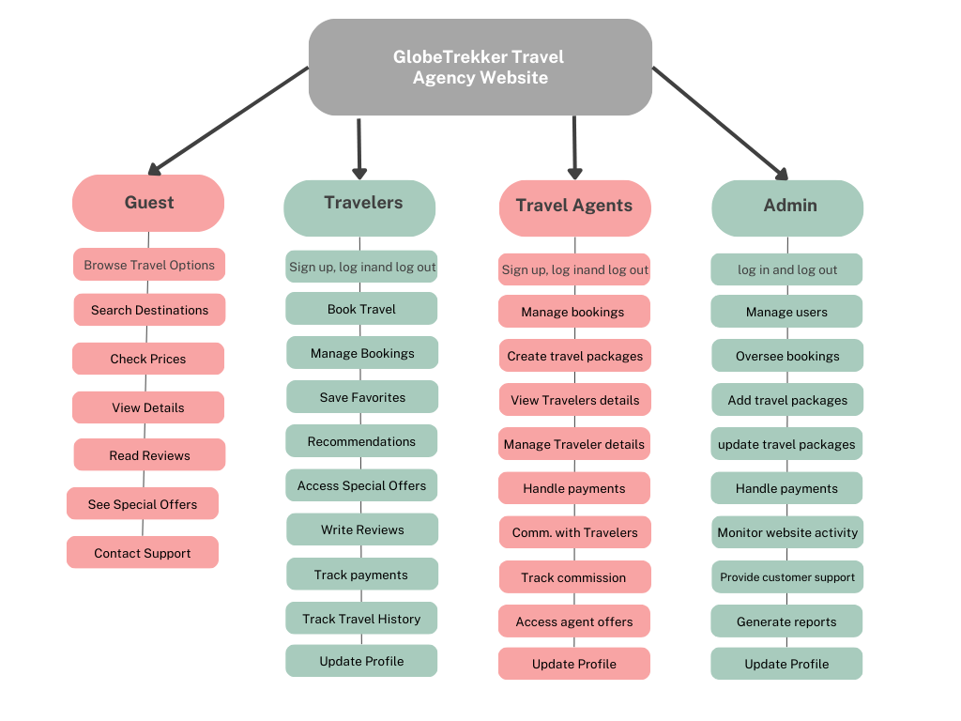

* **DFD level-1 diagram of Guest**

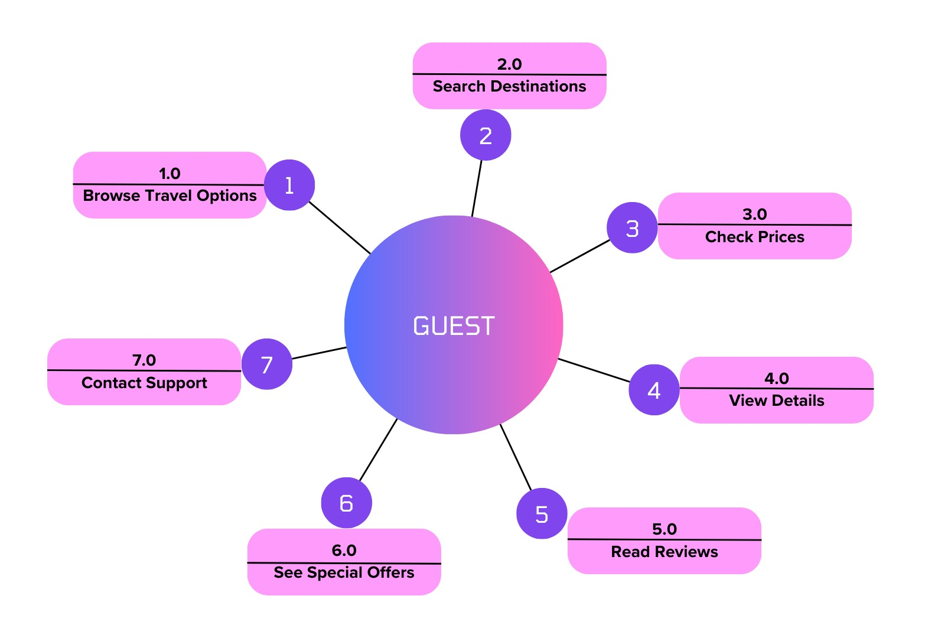

* **DFD level-1 diagram of Admin**

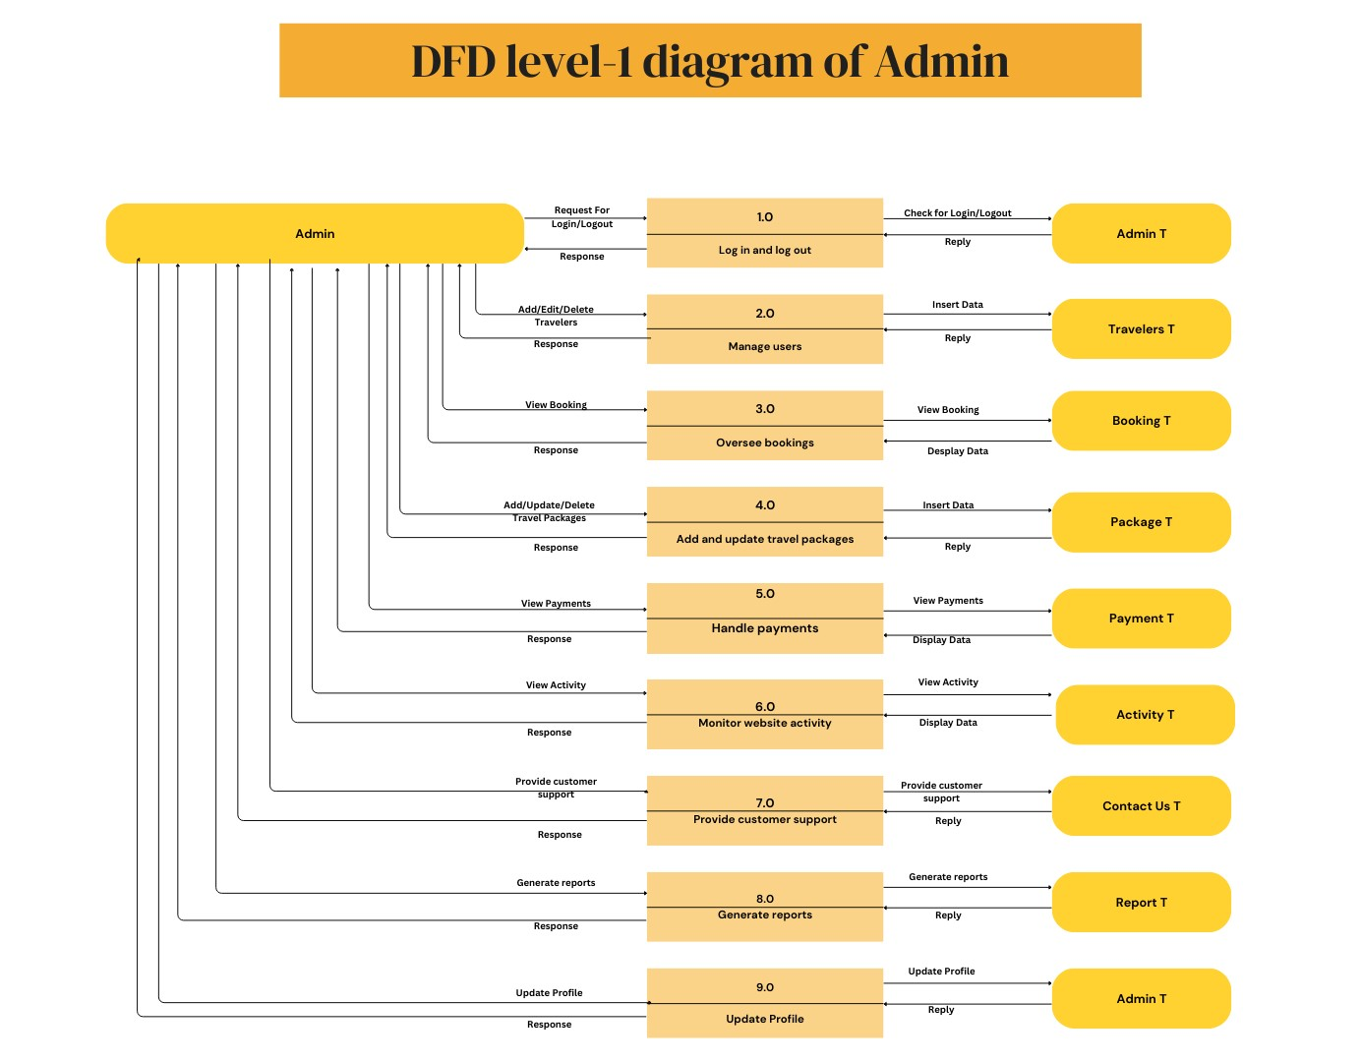

* **DFD level-1 diagram of Travelers**

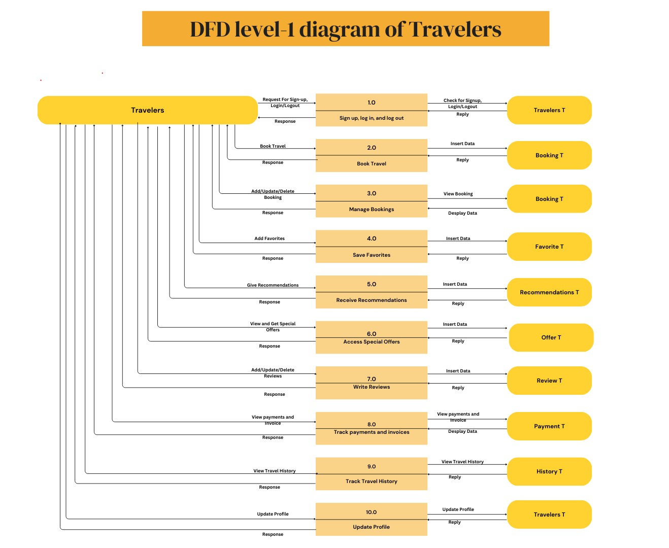

* **DFD level-1 diagram of Travel-Agents**

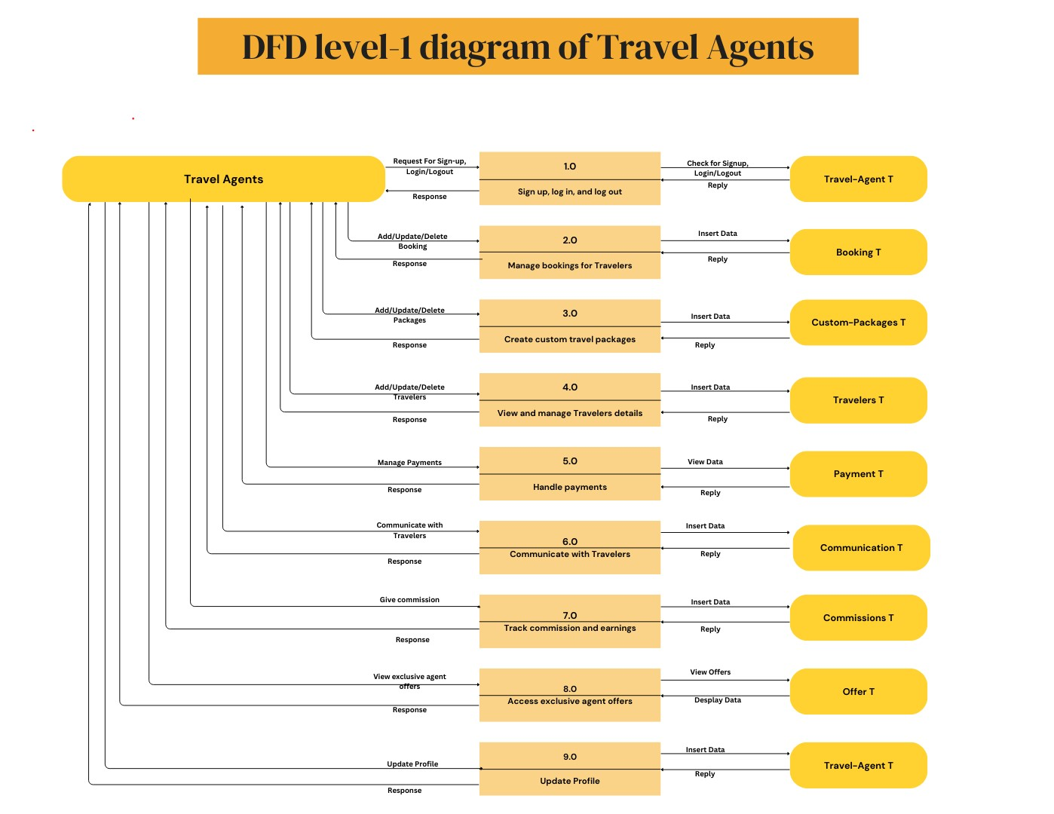

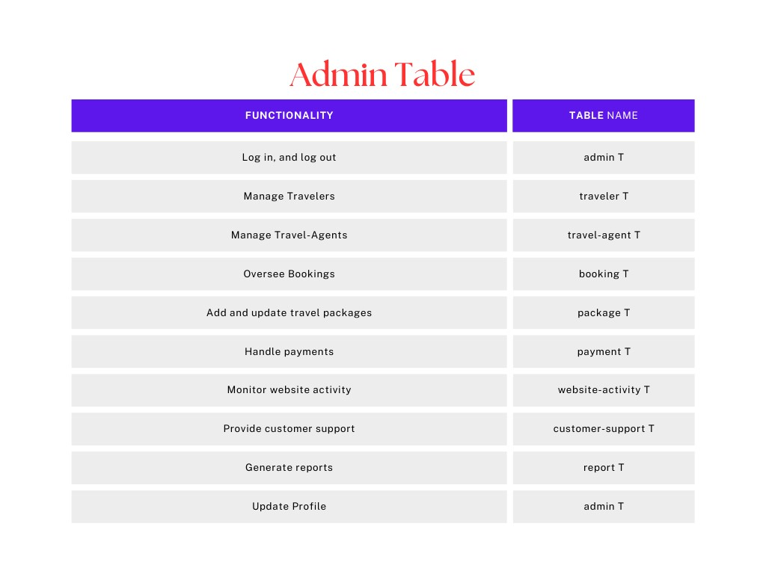

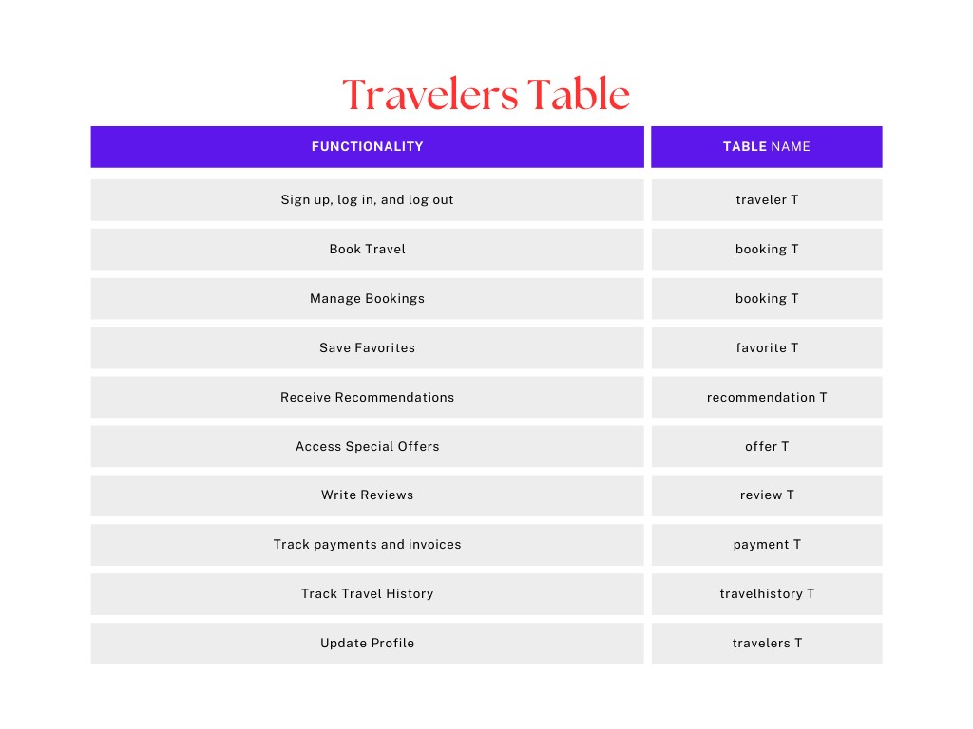

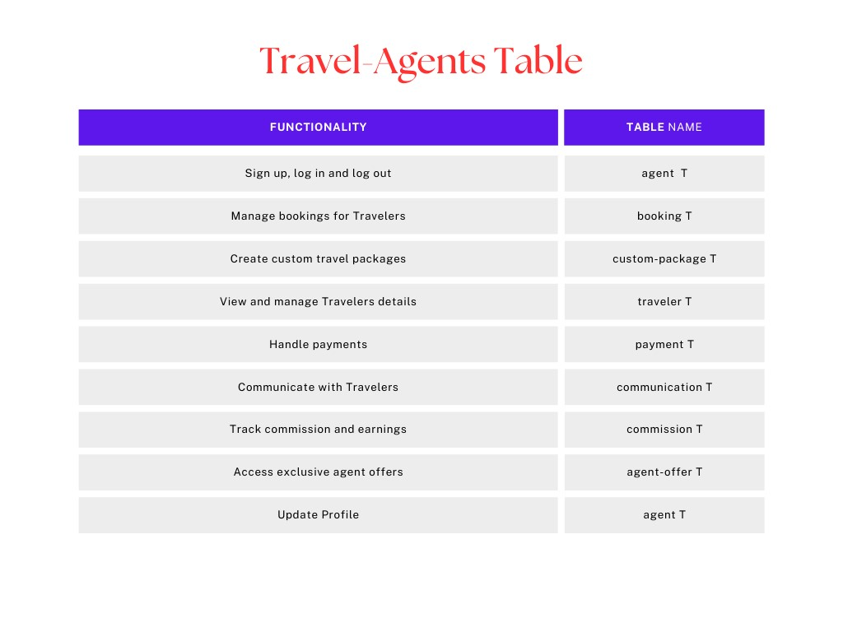

**Total No. of Tables**

* Admin
* Traveller
* Travel-Agent
* Booking
* Package
* Payment
* Website-Activity
* Customer-Support
* Report
* Favorite
* Recommendation
* Offer
* Review
* Travel-History
* Custom-Package
* Communication
* Commision
* Agent-Offer

### ****Table Name:**** Admin Table

| **Column Name** |  | **Data Type** |  | **Description** |
| --- | --- | --- | --- | --- |
| **admin_id** |  | INT (Primary Key, Auto Increment) |  | A unique identifier for each admin user. |
| **Admin_name** |  | VARCHAR(50) |  | The admin's username for logging in. |
| **email** |  | VARCHAR(100) |  | The admin's email address. |
| **password** |  | VARCHAR(255) |  | The encrypted/hashed password for secure login. |
| **role** |  | ENUM('superadmin', 'manager', 'staff') |  | The role of the admin (e.g., superadmin, manager). |
| **phone_number** |  | VARCHAR(15) |  | Contact number of the admin. |
| **profile_picture** |  | VARCHAR(255) |  | URL or path to the admin's profile picture (optional). |
| **status** |  | ENUM('active', 'inactive') |  | Indicates whether the admin account is active or inactive. |
| **created_at** |  | TIMESTAMP |  | The timestamp when the admin account was created. |
| **updated_at** |  | TIMESTAMP |  | The timestamp for the last update to the admin account. |

### ****Table Name:**** Traveller Table

| **Column Name** |  | **Data Type** |  | **Description** |
| --- | --- | --- | --- | --- |
| **traveller_id** |  | INT (Primary Key, Auto Increment) |  | A unique identifier for each traveler. |
| **first_name** |  | VARCHAR(50) |  | The traveler's first name. |
| **last_name** |  | VARCHAR(50) |  | The traveler's last name. |
| **email** |  | VARCHAR(100) |  | Contact email address of the traveler. |
| **phone_number** |  | VARCHAR(15) |  | Contact phone number of the traveler. |
| **date_of_birth** |  | DATE |  | The traveler's date of birth (optional but useful for age-related services). |
| **gender** |  | ENUM('male', 'female', 'other') |  | Gender of the traveler. |
| **passport_number** |  | VARCHAR(20) |  | The traveler's passport number (if applicable for international trips). |
| **address** |  | TEXT |  | The traveler's address for billing or correspondence purposes. |
| **emergency_contact** |  | VARCHAR(100) |  | Contact details for emergencies (name and phone number). |
| **travel_history** |  | JSON |  | JSON field to store past travel details (destinations, dates, etc.). |
| **status** |  | ENUM('active', 'inactive') |  | Indicates if the traveler is currently active in the system. |
| **created_at** |  | TIMESTAMP |  | The timestamp when the traveler record was created. |
| **updated_at** |  | TIMESTAMP |  | The timestamp for the last update to the traveler record. |

### ****Table Name:**** Travel Agent Table

| **Column Name** |  | **Data Type** |  | **Description** |
| --- | --- | --- | --- | --- |
| **agent_id** |  | INT (Primary Key, Auto Increment) |  | A unique identifier for each travel agent. |
| **first_name** |  | VARCHAR(50) |  | The agent's first name. |
| **last_name** |  | VARCHAR(50) |  | The agent's last name. |
| **email** |  | VARCHAR(100) |  | The agent's contact email (used for communication and login). |
| **phone_number** |  | VARCHAR(15) |  | Contact number of the agent. |
| **address** |  | TEXT |  | Address of the travel agent (optional). |
| **role** |  | ENUM('admin', 'sales', 'support') |  | The agent's role (e.g., admin, sales, or support staff). |
| **agency_name** |  | VARCHAR(100) |  | Name of the travel agency the agent is associated with (if applicable). |
| **profile_picture** |  | VARCHAR(255) |  | URL or path to the agent's profile picture. |
| **status** |  | ENUM('active', 'inactive') |  | Indicates whether the agent is currently active in the system. |
| **assigned_customers** |  | INT |  | The number of customers assigned to the agent (optional). |
| **total_bookings** |  | INT |  | The total number of bookings handled by the agent. |
| **created_at** |  | TIMESTAMP |  | The timestamp when the agent account was created. |
| **updated_at** |  | TIMESTAMP |  | The timestamp for the last update to the agent's record. |

### ****Table Name:**** Booking Table

| **Column Name** |  | **Data Type** |  | **Description** |
| --- | --- | --- | --- | --- |
| **booking_id** |  | INT (Primary Key, Auto Increment) |  | A unique identifier for each booking. |
| **traveller_id** |  | INT |  | Foreign key referencing the traveller_table to link the traveler to the booking. |
| **package_id** |  | INT |  | Foreign key referencing the travel_package_table to link the booked package. |
| **agent_id** |  | INT |  | Foreign key referencing the travel_agent_table for the agent handling the booking. |
| **destination** |  | VARCHAR(100) |  | The destination for the travel (e.g., Paris, Maldives). |
| **travel_date_start** |  | DATE |  | The start date of the trip. |
| **travel_date_end** |  | DATE |  | The end date of the trip. |
| **total_price** |  | DECIMAL(10, 2) |  | The total cost of the booking. |
| **payment_status** |  | ENUM('pending', 'completed', 'refunded', 'canceled') |  | Status of the payment for the booking. |
| **booking_status** |  | ENUM('confirmed', 'pending', 'canceled') |  | The overall status of the booking. |
| **number_of_travelers** |  | INT |  | Total number of people included in the booking. |
| **special_requests** |  | TEXT |  | Additional notes or requests made by the traveler (e.g., vegetarian meals). |
| **created_at** |  | TIMESTAMP |  | The timestamp when the booking was created. |
| **updated_at** |  | TIMESTAMP |  | The timestamp for the last update to the booking record. |

**Table Name: Package Table**

| **Column Name** |  | **Data Type** |  | **Description** |
| --- | --- | --- | --- | --- |
|  |  |  |  |  |
| **package_id** |  | INT (Primary Key, Auto Increment) |  | A unique identifier for each travel package. |
|  |  |  |  |  |
| **package_name** |  | VARCHAR(100) |  | The name of the travel package (e.g., "Luxury Maldives Getaway"). |
|  |  |  |  |  |
| **destination** |  | VARCHAR(100) |  | The main destination of the package. |
|  |  |  |  |  |
| **duration_days** |  | INT |  | The duration of the package in days. |
|  |  |  |  |  |
| **price_per_person** |  | DECIMAL(10, 2) |  | The cost of the package per person. |
|  |  |  |  |  |
| **start_date** |  | DATE |  | The start date for the package availability. |
|  |  |  |  |  |
| **end_date** |  | DATE |  | The end date for the package availability. |
|  |  |  |  |  |
| **description** |  | TEXT |  | A detailed description of the package, including itinerary and highlights. |
|  |  |  |  |  |
| **inclusions** |  | TEXT |  | Details about what's included (e.g., meals, accommodation, tours). |
|  |  |  |  |  |
| **exclusions** |  | TEXT |  | Details about what's not included (e.g., airfare, visa fees). |
|  |  |  |  |  |
| **available_seats** |  | INT |  | The number of seats available for the package. |
|  |  |  |  |  |
| **status** |  | ENUM('active', 'inactive') |  | Indicates whether the package is currently available. |
|  |  |  |  |  |
| **created_at** |  | TIMESTAMP |  | The timestamp when the package was created. |
|  |  |  |  |  |
| **updated_at** |  | TIMESTAMP |  | The timestamp for the last update to the package. |

**Table Name: Payment Table**

| **Column Name** |  | **Data Type** |  | **Description** |
| --- | --- | --- | --- | --- |
|  |  |  |  |  |
| **payment_id** |  | INT (Primary Key, Auto Increment) |  | A unique identifier for each payment. |
|  |  |  |  |  |
| **booking_id** |  | INT |  | Foreign key referencing the booking_table to link the payment to a booking. |
|  |  |  |  |  |
| **payment_date** |  | TIMESTAMP |  | The date and time when the payment was made. |
|  |  |  |  |  |
| **amount** |  | DECIMAL(10, 2) |  | The total amount paid for the booking. |
|  |  |  |  |  |
| **payment_method** |  | ENUM('credit_card', 'debit_card', 'paypal', 'bank_transfer', 'cash') |  | The method used for the payment. |
|  |  |  |  |  |
| **transaction_id** |  | VARCHAR(50) |  | A unique identifier for the transaction (provided by the payment gateway). |
|  |  |  |  |  |
| **status** |  | ENUM('pending', 'completed', 'failed', 'refunded') |  | The status of the payment transaction. |
|  |  |  |  |  |
| **receipt_url** |  | VARCHAR(255) |  | A link to the payment receipt (if available). |
|  |  |  |  |  |
| **created_at** |  | TIMESTAMP |  | The timestamp when the payment record was created. |
|  |  |  |  |  |
| **updated_at** |  | TIMESTAMP |  | The timestamp for the last update to the payment record. |

**Table Name: Website Activity Table**

| **Column Name** |  | **Data Type** |  | **Description** |
| --- | --- | --- | --- | --- |
|  |  |  |  |  |
| **activity_id** |  | INT (Primary Key, Auto Increment) |  | A unique identifier for each activity log. |
|  |  |  |  |  |
| **user_id** |  | INT |  | Foreign key referencing the traveller_table or travel_agent_table, depending on the user type. |
|  |  |  |  |  |
| **user_type** |  | ENUM('traveller', 'agent', 'admin') |  | Identifies the type of user performing the activity. |
|  |  |  |  |  |
| **activity_type** |  | VARCHAR(50) |  | Specifies the activity (e.g., 'view_package', 'make_booking', 'login'). |
|  |  |  |  |  |
| **activity_details** |  | TEXT |  | Optional details about the activity (e.g., package ID viewed, booking ID created). |
|  |  |  |  |  |
| **ip_address** |  | VARCHAR(45) |  | Stores the IP address of the user for security and logging purposes. |
|  |  |  |  |  |
| **user_agent** |  | TEXT |  | Information about the user's browser or device (e.g., browser type, OS). |
|  |  |  |  |  |
| **timestamp** |  | TIMESTAMP |  | The date and time when the activity occurred. |
|  |  |  |  |  |
| **status** |  | ENUM('success', 'failure') |  | Indicates whether the activity was successful or failed (e.g., login attempt). |

**Table Name: Customer Support Table**

| **Column Name** |  | **Data Type** |  | **Description** |
| --- | --- | --- | --- | --- |
|  |  |  |  |  |
| **support_id** |  | INT (Primary Key, Auto Increment) |  | A unique identifier for each customer support request. |
|  |  |  |  |  |
| **customer_id** |  | INT |  | Foreign key referencing the traveller_table or user_table, identifying the customer who created the request. |
|  |  |  |  |  |
| **request_date** |  | TIMESTAMP |  | The date and time when the support request was made. |
|  |  |  |  |  |
| **issue_type** |  | VARCHAR(100) |  | The type of issue (e.g., "payment issue", "booking cancellation", "technical support"). |
|  |  |  |  |  |
| **issue_description** |  | TEXT |  | A detailed description of the issue reported by the customer. |
|  |  |  |  |  |
| **status** |  | ENUM('open', 'in_progress', 'resolved', 'closed') |  | The current status of the support request. |
|  |  |  |  |  |
| **assigned_to** |  | INT |  | Foreign key referencing the support agent or team member handling the issue. |
|  |  |  |  |  |
| **resolution_summary** |  | TEXT |  | A brief description of how the issue was resolved (if resolved). |
|  |  |  |  |  |
| **resolution_date** |  | TIMESTAMP |  | The date and time when the issue was resolved (if applicable). |
|  |  |  |  |  |
| **priority** |  | ENUM('low', 'medium', 'high') |  | The priority level of the issue. |
|  |  |  |  |  |
| **follow_up_date** |  | TIMESTAMP |  | The date when the customer needs to be followed up (if applicable). |
|  |  |  |  |  |
| **created_at** |  | TIMESTAMP |  | The timestamp when the support request was created. |
|  |  |  |  |  |
| **updated_at** |  | TIMESTAMP |  | The timestamp for the last update to the support record. |

**Table Name: Report Table**

| **Column Name** |  | **Data Type** |  | **Description** |
| --- | --- | --- | --- | --- |
|  |  |  |  |  |
| **report_id** |  | INT (Primary Key, Auto Increment) |  | A unique identifier for each report. |
|  |  |  |  |  |
| **report_type** |  | VARCHAR(100) |  | The type of report (e.g., 'Sales Report', 'Booking Report', 'Customer Support Summary'). |
|  |  |  |  |  |
| **report_title** |  | VARCHAR(255) |  | The title or name of the report. |
|  |  |  |  |  |
| **generated_by** |  | INT |  | Foreign key referencing the admin_table or user_table to identify who generated the report. |
|  |  |  |  |  |
| **report_data** |  | TEXT |  | The content or data of the report (can be in a structured format like JSON, CSV, or raw text). |
|  |  |  |  |  |
| **report_date** |  | TIMESTAMP |  | The date and time when the report was generated. |
|  |  |  |  |  |
| **report_period_start** |  | DATE |  | The start date of the period the report covers (e.g., monthly, quarterly). |
|  |  |  |  |  |
| **report_period_end** |  | DATE |  | The end date of the period the report covers. |
|  |  |  |  |  |
| **status** |  | ENUM('generated', 'pending', 'archived') |  | The status of the report (generated, pending, archived). |
|  |  |  |  |  |
| **created_at** |  | TIMESTAMP |  | The timestamp when the report record was created. |
|  |  |  |  |  |
| **updated_at** |  | TIMESTAMP |  | The timestamp for the last update to the report record. |

**Table Name: Favorite Table**

| **Column Name** |  |  | **Data Type** |  |  | **Description** |
| --- | --- | --- | --- | --- | --- | --- |
|  |  |  |  |  |  |  |
| **favorite_id** |  |  | INT (Primary Key, Auto Increment) |  |  | A unique identifier for each favorite record. |
|  |  |  |  |  |  |  |
| **user_id** |  |  | INT |  |  | Foreign key referencing the traveller_table or user_table to identify the user who added the favorite. |
|  |  |  |  |  |  |  |
| **item_id** |  |  | INT |  |  | The ID of the item marked as a favorite (e.g., package, destination). Can reference different tables (like package_table, destination_table). |
|  |  |  |  |  |  |  |
| **item_type** |  |  | ENUM('package', 'destination', 'offer') |  |  | Specifies the type of item (e.g., a package, destination, or offer). |
|  |  |  |  |  |  |  |
| **added_at** |  |  | TIMESTAMP |  |  | The date and time when the item was added to the favorites list. |
|  |  |  |  |  |  |  |
| **status** |  |  | ENUM('active', 'removed') |  |  | The status of the favorite (active, or removed from favorites). |
|  |  |  |  |  |  |  |
| **created_at** |  |  | TIMESTAMP |  |  | The timestamp when the favorite record was created. |
|  |  |  |  |  |  |  |
| **updated_at** |  |  | TIMESTAMP |  |  | The timestamp for the last update to the favorite record. |

**Table Name: Recommendation Table**

| **Column Name** |  |  | **Data Type** |  |  | **Description** |
| --- | --- | --- | --- | --- | --- | --- |
|  |  |  |  |  |  |  |
| **recommendation_id** |  |  | INT (Primary Key, Auto Increment) |  |  | A unique identifier for each recommendation. |
|  |  |  |  |  |  |  |
| **user_id** |  |  | INT |  |  | Foreign key referencing the traveller_table or user_table, identifying the user who received the recommendation. |
|  |  |  |  |  |  |  |
| **item_id** |  |  | INT |  |  | The ID of the item that was recommended (e.g., a package, destination, offer). Can reference different tables like package_table, destination_table. |
|  |  |  |  |  |  |  |
| **item_type** |  |  | ENUM('package', 'destination', 'offer') |  |  | Specifies the type of recommended item (e.g., travel package, destination, or promotional offer). |
|  |  |  |  |  |  |  |
| **recommendation_source** |  |  | VARCHAR(255) |  |  | Describes how or why the recommendation was made (e.g., "based on favorite destinations", "popular among similar users"). |
|  |  |  |  |  |  |  |
| **recommended_at** |  |  | TIMESTAMP |  |  | The date and time when the recommendation was made to the user. |
|  |  |  |  |  |  |  |
| **status** |  |  | ENUM('pending', 'viewed', 'accepted', 'dismissed') |  |  | The status of the recommendation (e.g., whether it was viewed, accepted, or dismissed). |
|  |  |  |  |  |  |  |
| **created_at** |  |  | TIMESTAMP |  |  | The timestamp when the recommendation record was created. |
|  |  |  |  |  |  |  |
| **updated_at** |  |  | TIMESTAMP |  |  | The timestamp for the last update to the recommendation record. |

**Table Name: Offer Table**

| **Column Name** |  |  | **Data Type** |  | **Description** |
| --- | --- | --- | --- | --- | --- |
|  |  |  |  |  |  |
| **offer_id** |  |  | INT (Primary Key, Auto Increment) |  | A unique identifier for each offer. |
|  |  |  |  |  |  |
| **offer_title** |  |  | VARCHAR(255) |  | The title or name of the offer (e.g., "Winter Sale", "Summer Discount"). |
|  |  |  |  |  |  |
| **offer_description** |  |  | TEXT |  | A detailed description of the offer, including terms and conditions. |
|  |  |  |  |  |  |
| **discount_percentage** |  |  | DECIMAL(5,2) |  | The discount percentage of the offer (e.g., 10.50 for a 10.5% discount). |
|  |  |  |  |  |  |
| **offer_type** |  |  | ENUM('flat_discount', 'percentage_discount', 'buy_one_get_one') |  | Specifies the type of offer (e.g., flat discount, percentage discount, etc.). |
|  |  |  |  |  |  |
| **valid_from** |  |  | TIMESTAMP |  | The start date and time when the offer becomes valid. |
|  |  |  |  |  |  |
| **valid_to** |  |  | TIMESTAMP |  | The end date and time when the offer expires. |
|  |  |  |  |  |  |
| **target_audience** |  |  | VARCHAR(100) |  | Specifies the target audience for the offer (e.g., "New Customers", "Returning Customers", "All Users"). |
|  |  |  |  |  |  |
| **status** |  |  | ENUM('active', 'expired', 'upcoming') |  | The status of the offer (active, expired, or upcoming). |
|  |  |  |  |  |  |
| **created_at** |  |  | TIMESTAMP |  | The timestamp when the offer record was created. |
|  |  |  |  |  |  |
| **updated_at** |  |  | TIMESTAMP |  | The timestamp for the last update to the offer record. |

**Table Name: Review Table**

| **Column Name** |  |  | **Data Type** |  |  | **Description** |
| --- | --- | --- | --- | --- | --- | --- |
|  |  |  |  |  |  |  |
| **review_id** |  |  | INT (Primary Key, Auto Increment) |  |  | A unique identifier for each review. |
|  |  |  |  |  |  |  |
| **user_id** |  |  | INT |  |  | Foreign key referencing the traveller_table or user_table, identifying the user who submitted the review. |
|  |  |  |  |  |  |  |
| **item_id** |  |  | INT |  |  | The ID of the item being reviewed (e.g., package, destination, hotel, etc.). Can reference tables like package_table, destination_table. |
|  |  |  |  |  |  |  |
| **item_type** |  |  | ENUM('package', 'destination', 'hotel', 'tour') |  |  | Specifies the type of item being reviewed (e.g., travel package, destination, hotel). |
|  |  |  |  |  |  |  |
| **rating** |  |  | INT |  |  | The rating given by the user, typically on a scale from 1 to 5 (or 1 to 10). |
|  |  |  |  |  |  |  |
| **review_comment** |  |  | TEXT |  |  | A detailed comment or feedback provided by the user about the item. |
|  |  |  |  |  |  |  |
| **review_date** |  |  | TIMESTAMP |  |  | The date and time when the review was submitted. |
|  |  |  |  |  |  |  |
| **status** |  |  | ENUM('approved', 'pending', 'rejected') |  |  | The status of the review (approved, pending moderation, or rejected). |
|  |  |  |  |  |  |  |
| **created_at** |  |  | TIMESTAMP |  |  | The timestamp when the review record was created. |
|  |  |  |  |  |  |  |
| **updated_at** |  |  | TIMESTAMP |  |  | The timestamp for the last update to the review record. |

**Table Name: Travel History Table**

| **Column Name** |  | **Data Type** |  | **Description** |
| --- | --- | --- | --- | --- |
|  |  |  |  |  |
| **history_id** |  | INT (Primary Key, Auto Increment) |  | A unique identifier for each travel history record. |
|  |  |  |  |  |
| **user_id** |  | INT |  | Foreign key referencing the traveller_table or user_table, identifying the traveler. |
|  |  |  |  |  |
| **trip_id** |  | INT |  | A unique identifier for each trip or booking made. |
|  |  |  |  |  |
| **destination_id** |  | INT |  | Foreign key referencing the destination_table or package_table, identifying the destination visited or package booked. |
|  |  |  |  |  |
| **trip_start_date** |  | DATE |  | The start date of the trip. |
|  |  |  |  |  |
| **trip_end_date** |  | DATE |  | The end date of the trip. |
|  |  |  |  |  |
| **trip_status** |  | ENUM('booked', 'completed', 'cancelled', 'in_progress') |  | The current status of the trip (e.g., booked, completed, cancelled). |
|  |  |  |  |  |
| **booking_date** |  | TIMESTAMP |  | The date and time when the booking was made. |
|  |  |  |  |  |
| **total_amount** |  | DECIMAL(10,2) |  | The total amount paid for the trip or package. |
|  |  |  |  |  |
| **payment_status** |  | ENUM('paid', 'pending', 'failed') |  | The payment status of the trip (e.g., paid, pending, failed). |
|  |  |  |  |  |
| **created_at** |  | TIMESTAMP |  | The timestamp when the travel history record was created. |
|  |  |  |  |  |
| **updated_at** |  | TIMESTAMP |  | The timestamp for the last update to the travel history record. |

**Table Name: Custom Package Table**

| **Column Name** |  |  | **Data Type** |  | **Description** |
| --- | --- | --- | --- | --- | --- |
|  |  |  |  |  |  |
| **custom_package_id** |  |  | INT (Primary Key, Auto Increment) |  | A unique identifier for each custom travel package. |
|  |  |  |  |  |  |
| **user_id** |  |  | INT |  | Foreign key referencing the traveller_table or user_table, identifying the user who created the custom package. |
|  |  |  |  |  |  |
| **package_name** |  |  | VARCHAR(255) |  | The name of the custom package (e.g., "Luxury Honeymoon", "Family Adventure"). |
|  |  |  |  |  |  |
| **destination_ids** |  |  | TEXT |  | A list of destination IDs included in the custom package. This could be stored as a comma-separated list or in a separate table linking destinations to the custom package. |
|  |  |  |  |  |  |
| **accommodation_ids** |  |  | TEXT |  | A list of accommodation IDs included in the package (could reference hotel or lodging options). |
|  |  |  |  |  |  |
| **activity_ids** |  |  | TEXT |  | A list of activity IDs included in the package (could reference tours, excursions, etc.). |
|  |  |  |  |  |  |
| **transportation_ids** |  |  | TEXT |  | A list of transportation options (flight, train, etc.) included in the package. |
|  |  |  |  |  |  |
| **total_price** |  |  | DECIMAL(10,2) |  | The total price of the custom package. |
|  |  |  |  |  |  |
| **status** |  |  | ENUM('created', 'booked', 'completed', 'cancelled') |  | The current status of the custom package (e.g., created, booked, completed, cancelled). |
|  |  |  |  |  |  |
| **package_creation_date** |  |  | TIMESTAMP |  | The date and time when the custom package was created. |
|  |  |  |  |  |  |
| **booking_date** |  |  | TIMESTAMP |  | The date and time when the custom package was booked. |
|  |  |  |  |  |  |
| **payment_status** |  |  | ENUM('paid', 'pending', 'failed') |  | The payment status of the custom package (e.g., paid, pending, failed). |
|  |  |  |  |  |  |
| **created_at** |  |  | TIMESTAMP |  | The timestamp when the custom package record was created. |
|  |  |  |  |  |  |
| **updated_at** |  |  | TIMESTAMP |  | The timestamp for the last update to the custom package record. |

**Table Name: Communication Table**

| **Column Name** |  | **Data Type** |  | **Description** |
| --- | --- | --- | --- | --- |
|  |  |  |  |  |
| **communication_id** |  | INT (Primary Key, Auto Increment) |  | A unique identifier for each communication record. |
|  |  |  |  |  |
| **user_id** |  | INT |  | Foreign key referencing the traveller_table or user_table, identifying the user involved in the communication. |
|  |  |  |  |  |
| **communication_type** |  | ENUM('email', 'message', 'notification', 'call') |  | The type of communication (e.g., email, direct message, notification, call). |
|  |  |  |  |  |
| **subject** |  | VARCHAR(255) |  | The subject of the communication (e.g., booking confirmation, support request). |
|  |  |  |  |  |
| **message** |  | TEXT |  | The content of the communication (message body or notification content). |
|  |  |  |  |  |
| **sender_id** |  | INT |  | Foreign key referencing the admin_table, agent_table, or support_table, identifying the sender of the communication. |
|  |  |  |  |  |
| **receiver_id** |  | INT |  | Foreign key referencing the traveller_table, user_table, or other relevant tables, identifying the receiver. |
|  |  |  |  |  |
| **status** |  | ENUM('sent', 'received', 'read', 'replied', 'archived') |  | The current status of the communication (e.g., sent, received, read, replied). |
|  |  |  |  |  |
| **communication_date** |  | TIMESTAMP |  | The date and time when the communication was sent or received. |
|  |  |  |  |  |
| **priority** |  | ENUM('low', 'medium', 'high') |  | The priority level of the communication (e.g., low, medium, high). |
|  |  |  |  |  |
| **created_at** |  | TIMESTAMP |  | The timestamp when the communication record was created. |
|  |  |  |  |  |
| **updated_at** |  | TIMESTAMP |  | The timestamp for the last update to the communication record. |

**Table Name: Commission Table**

| **Column Name** |  |  | **Data Type** |  |  | **Description** |
| --- | --- | --- | --- | --- | --- | --- |
|  |  |  |  |  |  |  |
| **commission_id** |  |  | INT (Primary Key, Auto Increment) |  |  | A unique identifier for each commission record. |
|  |  |  |  |  |  |  |
| **booking_id** |  |  | INT |  |  | Foreign key referencing the booking_table, identifying the booking associated with the commission. |
|  |  |  |  |  |  |  |
| **agent_id** |  |  | INT |  |  | Foreign key referencing the agent_table or user_table, identifying the agent who earned the commission. |
|  |  |  |  |  |  |  |
| **commission_amount** |  |  | DECIMAL(10,2) |  |  | The commission amount earned by the agent for the booking or sale. |
|  |  |  |  |  |  |  |
| **commission_percentage** |  |  | DECIMAL(5,2) |  |  | The percentage of the total booking amount that constitutes the commission. |
|  |  |  |  |  |  |  |
| **payment_status** |  |  | ENUM('paid', 'pending', 'failed') |  |  | The status of the commission payment (e.g., paid, pending, failed). |
|  |  |  |  |  |  |  |
| **commission_date** |  |  | TIMESTAMP |  |  | The date and time when the commission was earned or calculated. |
|  |  |  |  |  |  |  |
| **payment_date** |  |  | TIMESTAMP |  |  | The date and time when the commission payment was made (if applicable). |
|  |  |  |  |  |  |  |
| **created_at** |  |  | TIMESTAMP |  |  | The timestamp when the commission record was created. |
|  |  |  |  |  |  |  |
| **updated_at** |  |  | TIMESTAMP |  |  | The timestamp for the last update to the commission record. |

**Table Name: Agent Offer Table**

| **Column Name** |  |  | **Data Type** |  |  | **Description** |
| --- | --- | --- | --- | --- | --- | --- |
|  |  |  |  |  |  |  |
|  |  |  |  |  |  |  |
| **offer_id** |  |  | INT (Primary Key, Auto Increment) |  |  | A unique identifier for each offer record. |
|  |  |  |  |  |  |  |
| **agent_id** |  |  | INT |  |  | Foreign key referencing the agent_table or user_table, identifying the agent who created the offer. |
|  |  |  |  |  |  |  |
| **offer_title** |  |  | VARCHAR(255) |  |  | A brief title or name of the offer (e.g., "Summer Special", "Winter Discount"). |
|  |  |  |  |  |  |  |
| **offer_description** |  |  | TEXT |  |  | A detailed description of the offer (e.g., terms, conditions, duration). |
|  |  |  |  |  |  |  |
| **offer_code** |  |  | VARCHAR(50) |  |  | A unique code that the customer can use to avail the offer (e.g., "SUMMER20"). |
|  |  |  |  |  |  |  |
| **discount_percentage** |  |  | DECIMAL(5,2) |  |  | The percentage discount offered on bookings or packages. |
|  |  |  |  |  |  |  |
| **valid_from** |  |  | TIMESTAMP |  |  | The start date of the offer's validity. |
|  |  |  |  |  |  |  |
| **valid_until** |  |  | TIMESTAMP |  |  | The end date of the offer's validity. |
|  |  |  |  |  |  |  |
| **is_active** |  |  | BOOLEAN |  |  | A flag indicating whether the offer is currently active (TRUE or FALSE). |
|  |  |  |  |  |  |  |
| **created_at** |  |  | TIMESTAMP |  |  | The timestamp when the offer record was created. |
|  |  |  |  |  |  |  |
| **updated_at** |  |  | TIMESTAMP |  |  | The timestamp for the last update to the offer record. |

**Admin Panel:-**

**Log in and log out admin login.jsx**

**Dashboard admin Dashboard.jsx**

**Manage user traveller T/F**

**Manage user travel_agent T/F**

**Oversee bookings booking T**

**Add and update travel packages packages T/F**

**Handle payments payments T**

**Monitor website activity website_activity T**

**Provide customer support customer support T**

**Generate reports reports T**

**Update Profile admin T**